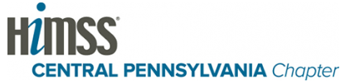
2016 Fall Education Event
Population Health & Applied Data Analytics
September 13-14, 2016
Hosted by:

Please join us in September for our Fall Educational Event. It is a great networking event that allows for many opportunities to interact with colleagues working in Health Information Technology. Our speaking lineup includes top CIOs from the region, Senior leadership of Geisinger, and Data Analytics experts from Mayo and all will be in the various events we have planned over the two days.

Keynote Speakers:
Morning: Marc Williams, M.D., PhD, Director, Geisinger Genomics Medicine Institute
Afternoon: John Kravitz, Geisinger CIO

Presentation of Use Case: Dwight Brown, Director of Enterprise Architecture, Mayo Clinic & Sanjay Pudupakkam, CEO Avatar EBS

Population Health Applied Data Analytics Panel

Healthcare 2025: John McDaniel, VP Innovation, HCI Group

Healthcare CIO and Leadership Discussion:
Tim Schoener, CIO, Susquehanna Health
Marie Roof, CIO, VIBRA Healthcare
Katherine Schneider, CEO, Delaware Valley ACO
Neil Gomes, VP of Innovation Technology & Patient Experience, Jefferson Health
Frank Richards, CIO Emeritus, Geisinger
Cost: $45.00 for HIMSS Members/$75.00 for Non-Members Includes: Breakfast, Lunch & Free Parking

Registration: https://secure100.telusys.net/tcsc-bin/regdisplay?8867477543936450
Directions: http://www.pinebarninn.com/pinebarn/hotel/directions.html
THANK YOU TO OUR SILVER SPONSORS:
RUBY – PRE-EVENT DINNER SPONSORSHIP- SOLD OUT
THANK YOU TO OUR CHAPTER SPONSOR: 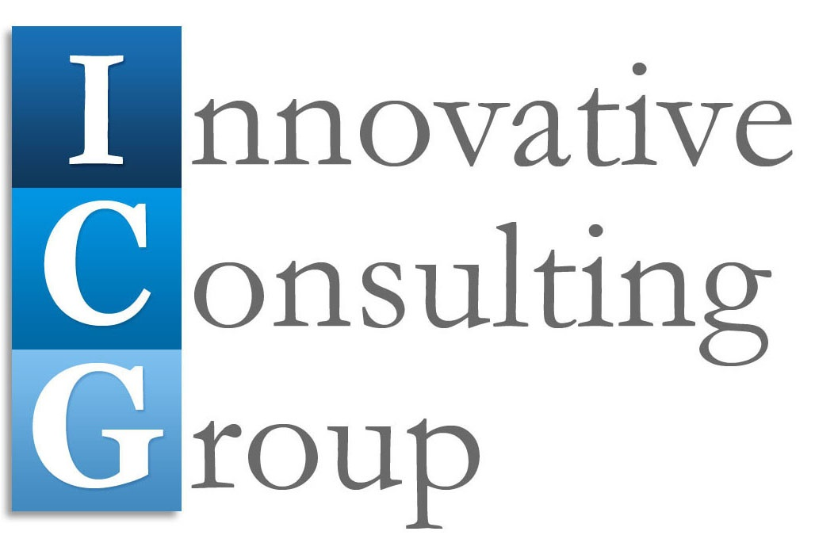
We are currently seeking sponsors with products or services related to population health and applied data analytics specifically for this event. For more information, please contact our Sponsorship Chair, Kim Ireland, at kim@medstatix.com or 717-283-2220

